**Student lifestyle on bases on their GPA**

BovasBenson

DeVos Graduate School, Northwood University

MTH 650: Introduction to Data Analytics

Dr. Itauma Itauma

February 25th, 2025

**Analysis of Students' Lifestyle and Academic Performance**

**Introduction:**

Lifestyle choices of students significantly affect their academic performance. Study hours, sleep time, social interaction, extracurricular activity involvement, and physical activity impact whether or not students can successfully manage their time and live a balanced academic life. The study aims to identify how the factors relate to the Grade Point Average (GPA) of students using statistical techniques such as correlation analysis and regression analysis

**Problem Statement:**

It is necessary to know the relationship between students' daily life and study to optimize study habits and achieve better academic performance. The current study seeks to address the following questions:  
.How do study hours in class, sleeping time, extracurricular activities, and socializing affect GPA?  
.What are students' trade-offs between academic performance and other daily activities?  
.What are the patterns of time distribution across activities among students?

**Dataset Description:**

The data set includes several different variables about students' lives that can affect how well they are doing in school. It logs how many hours the students study each day and how much time is spent on things like sports or clubs. It also logs how many hours the students sleep each night, how many hours they spend with friends, and how many hours they spend exercising. The data set also includes each student's GPA to show how well the individual is doing in school.

**Independent and Dependent Variables:**

The independent variables in this study include study hours, sleep hours, extracurricular activities, social hours, and physical activity. The dependent variable is the GPA (Grade Point Average), which represents students’ academic performance.

**Descriptive Analysis:**

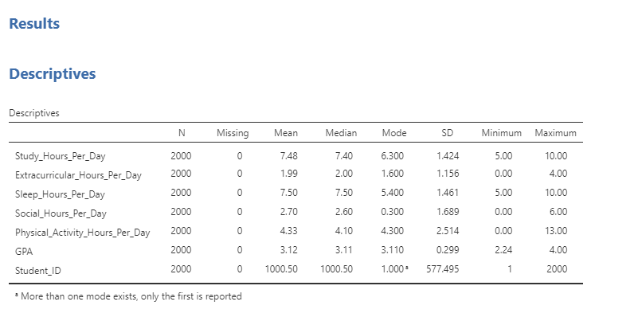

**Figure-1**

This section provides a summary of the most significant lifestyle variables among students. Students study an average of 7.48 hours a day, with a range of between 5 and 10 hours, dedicating most of their time to studying. Students use about 1.99 hours daily on extracurricular activities, while others do not spend any time on them at all. Most people sleep 7.5 hours a night, with a range of 5 to 10 hours. Students use an average of 2.7 hours a day socializing, with some doing hardly any at all. Students differ on the amount of exercise, with an average of 4.33 hours a day. The average GPA is 3.12, and most students do well in school.

**Histogram:**

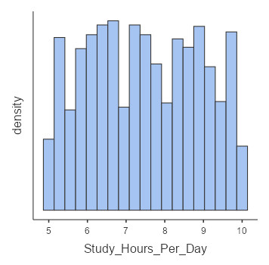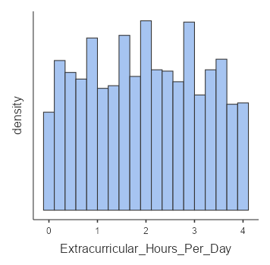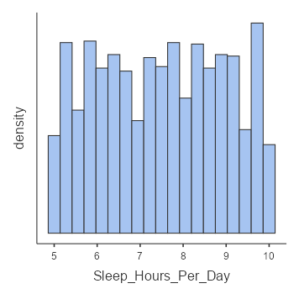

**Figure-2 Figure-3 Figure-4**

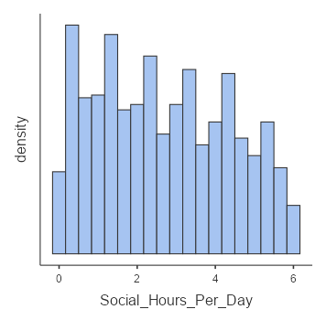

**Figure-5**

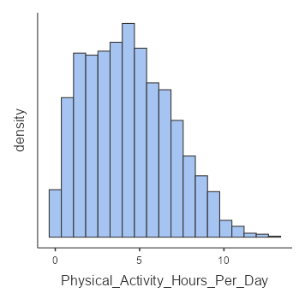 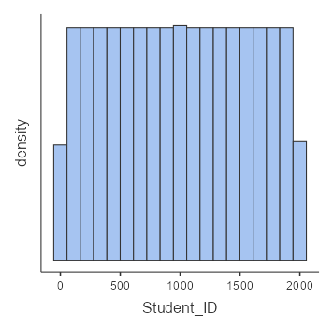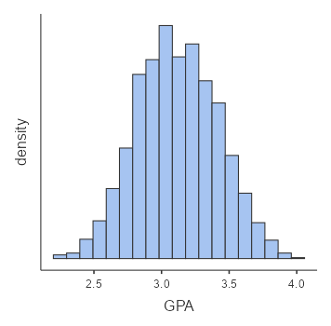

**Figure-6 Figure-7 Figure-8**

Histograms show the spread of different student activities. Study habits are different, with most of the students studying 7 to 8 hours per day. Sleeping hours range from 5 to 10 hours. There are students who spend a lot of time socializing with friends, and some students don't socialize at all. The level of involvement in extracurricular activities differs, with some students being involved a lot and some not being involved at all. Physical activity levels also vary widely, as some students exercise a great deal and others do not exercise at all. The GPA is normally distributed, with most students' GPAs clustered near the mean.

**Correlation Matrix Analysis:**

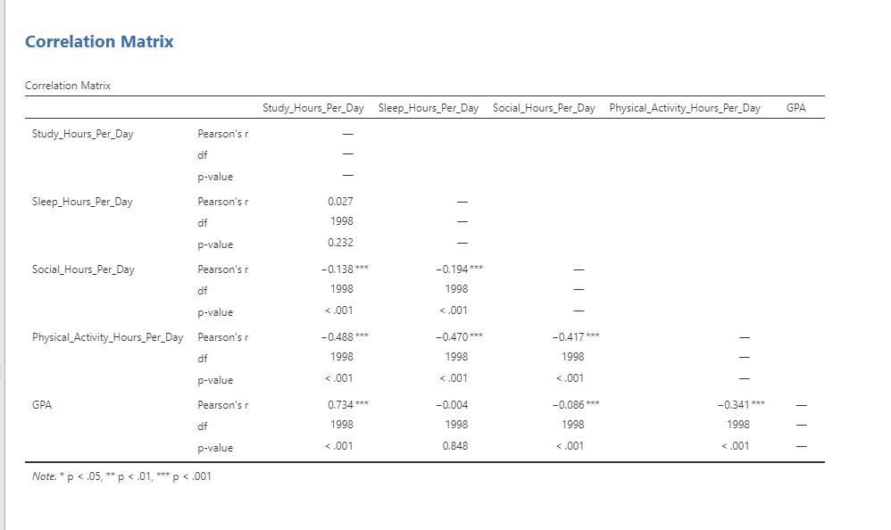

**Figure-9**

The correlation matrix shows student activity and GPA. There is a strong positive correlation (r = 0.734) between study hours and GPA, which means that students who study more have higher grades. Study hours also show a negative correlation with social hours (r = -0.138), meaning that students who study more also spend fewer social hours. There is a negative correlation (r = -0.488) between exercise time and study time, reflecting that the students who exercise study less. A negative correlation (r = -0.194) exists for sleep time with social time, reflecting that the students who sleep more spend less time on social activities. Also, physical activity is related to lower GPAs (r = -0.341), meaning students who engage in physical activity have slightly lower GPAs.

**Linear Regression Analysis:**

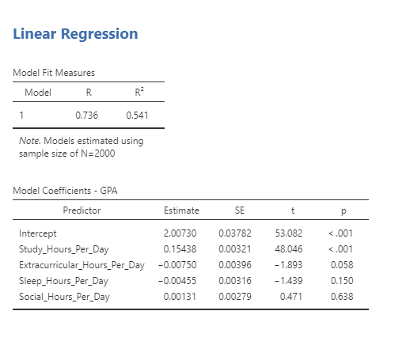 **Figure-10**

Linear regression helps in finding the effect of different activities on GPA. With every extra hour of studying, GPA rises by 0.154, a very positive effect. Extracurricular activity has a negligible negative effect (-0.0075) on GPA, though this is not statistically significant. Sleep hours have a very negligible negative effect (-0.0045) and are not significant. Social hours have an exceedingly small positive effect (0.0013) on GPA, though this again is not statistically significant. The analysis of model fit indicates that 54.1% of the variation in GPA (R² = 0.541) is accounted for by the independent variables. This implies that academic performance is also influenced by other external factors.

**Key Takeaways:**

Focusing on study time greatly improves GPA.

Involvement in extracurricular activities and social functions does not harm academic performance significantly.

Students should effectively manage time in order to optimize academic and personal well-being.

This research offers informative data about students' behavior and how it impacts their performance in school. It helps students who want to regulate their daily lives better.

**Conclusion:**

The study shows that study hours are very important in attaining high grades. Sleep, social life, and extracurricular activities have no major impact. Exercise is linked with lower GPAs, which means that students who engage in exercise will study less.

**Reference:**

https://www.kaggle.com/datasets/steve1215rogg/student-lifestyle-dataset

. Hershner, S. D., & Chervin, R. D. (2014). Causes and consequences of sleepiness among college students. *Nature and Science of Sleep, 6*, 73-84. <https://doi.org/10.2147/NSS.S62907>

. Topping, K. J. (1996). The effectiveness of peer tutoring in further and higher education: A typology and review of the literature. *Higher Education, 32*(3), 321-345. <https://doi.org/10.1007/BF00138870>

. Singh, A., Uijtdewilligen, L., Twisk, J. W., Van Mechelen, W., & Chinapaw, M. J. (2012). Physical activity and performance at school. *Archives of Pediatrics & Adolescent Medicine, 166*(1), 49-55. <https://doi.org/10.1001/archpediatrics.2011.716>

The jamovi project (2024). *jamovi*. (Version 2.6) [Computer Software]. Retrieved from <https://www.jamovi.org>.